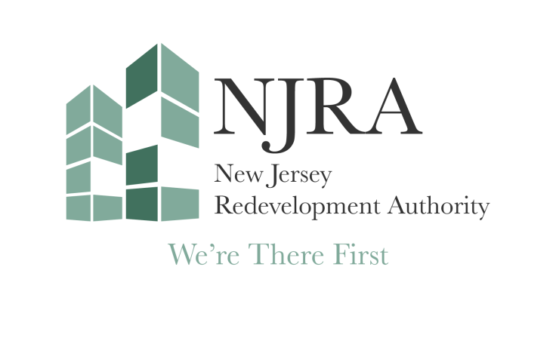
3/31/2026

New Jersey Redevelopment Authority Board Meeting on Wednesday, April 22, 2026, has been cancelled.

