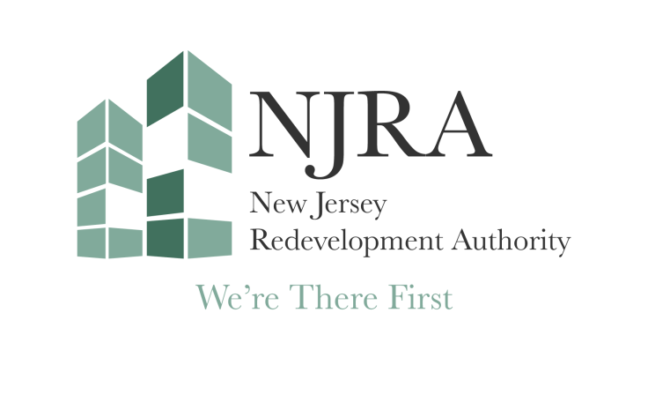Legal Notice
The NJ Redevelopment Authority board meeting scheduled for Wednesday, May 27, 2026, is cancelled.

