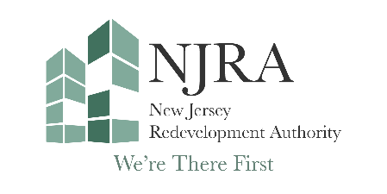

New Jersey Redevelopment Authority
150 West State St., Second Floor

P.O. Box 790
Trenton, NJ 08625
(609) 292-3739

NJRA Special Public Board Meeting

Meeting Date: Monday, March, 16 2026

Time: 10:00 AM

Ways to Attend
In Person
NJRA Offices
150 West State Street
2nd Floor
Trenton, New Jersey 08625

Zoom
https://us02web.zoom.us/j/81459076213?pwd=ehmCaroSbFfVQdDPl2HkyNRriuGbLa.1
Meeting ID: 814 5907 6213
Passcode: 470889

Phone
1 (646) 931-3860
Meeting ID: 814 5907 6213
Passcode: 470889
One touch dialing
+16469313860,,81459076213#,,,,*470889#

Please note: This is a proposed agenda, and the NJRA may consider and take action on such other business which may come before it at this special public meeting. In addition, in the NJRA’s discretion, items listed below in the proposed agenda may not be acted upon.

NEW JERSEY REDEVELOPMENT AUTHORITY
March 16, 2026
150 West State Street
Trenton, New Jersey 08625
10:00 AM
AGENDA

- NOTICE OF PUBLIC MEETING
- ROLL CALL
- CHAIRMAN’S REMARKS
- EXECUTIVE SESSION
  - To discuss personnel matters
- NEW BUSINESS
  - Resolution #26-07 Approval of up to $950,00 in financial assistance from Urban Site Acquisition (USA) to School Renewal SPE LLC
  - Resolution #26-08 Approval of an extension of the closing date for Walter G. Alexander IV Urban Renewal LLC
- PUBLIC COMMENT

- ADJOURNMENT

The New Jersey Redevelopment Authority is a financing agency that provides a creative approach to redevelopment efforts in New Jersey’s cities. The NJRA develops programs and resources to improve the quality of life by creating value in urban communities.

